



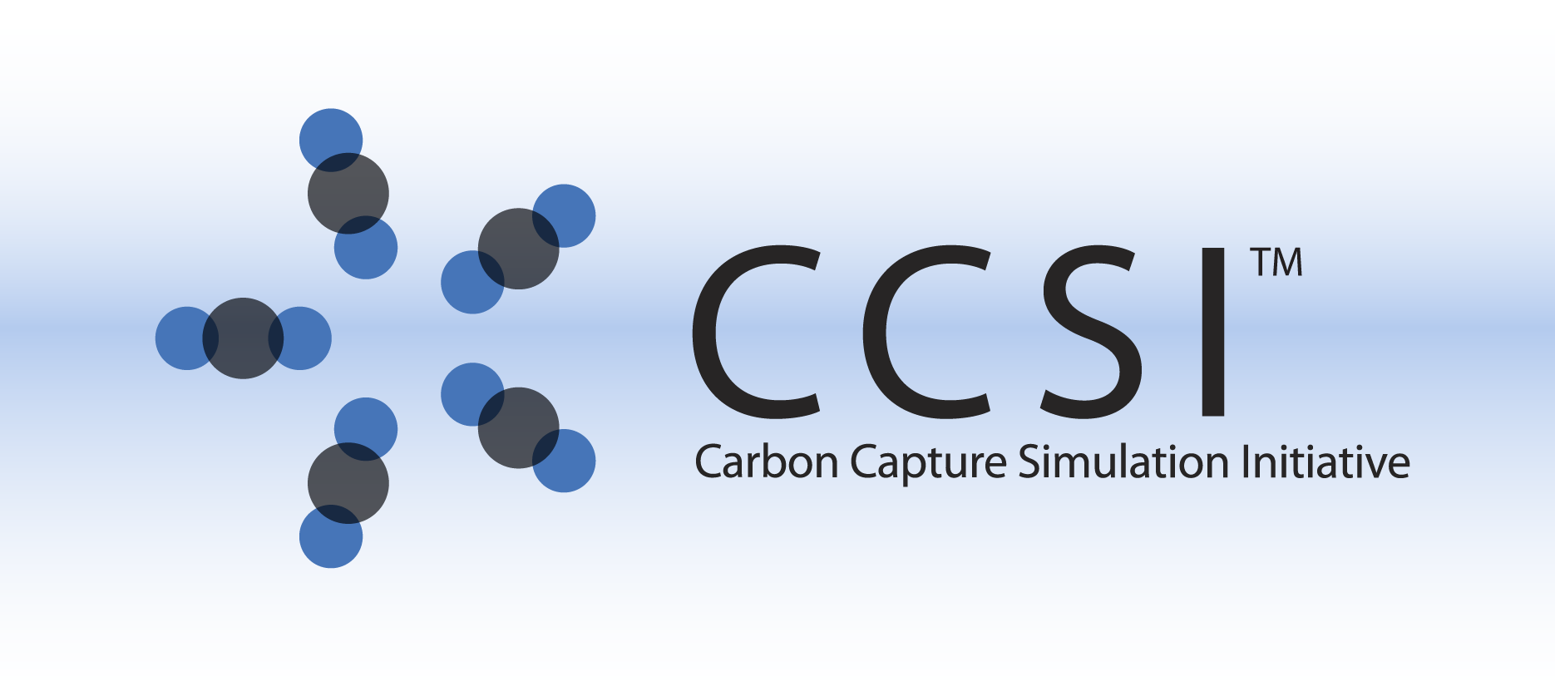

Moving Bed Reactor Model

User Manual

Version 2.0.0

March 2018

Copyright (c) 2012 - 2018

**Copyright Notice**

Moving Bed Reactor Model was produced under the DOE Carbon Capture Simulation Initiative (CCSI), and is copyright (c) 2012 - 2018 by the software owners: Oak Ridge Institute for Science and Education (ORISE), Los Alamos National Security, LLC., Lawrence Livermore National Security, LLC., The Regents of the University of California, through Lawrence Berkeley National Laboratory, Battelle Memorial Institute, Pacific Northwest Division through Pacific Northwest National Laboratory, Carnegie Mellon University, West Virginia University, Boston University, the Trustees of Princeton University, The University of Texas at Austin, URS Energy & Construction, Inc., et al.. All rights reserved.

NOTICE. This Software was developed under funding from the U.S. Department of Energy and the U.S. Government consequently retains certain rights. As such, the U.S. Government has been granted for itself and others acting on its behalf a paid-up, nonexclusive, irrevocable, worldwide license in the Software to reproduce, distribute copies to the public, prepare derivative works, and perform publicly and display publicly, and to permit other to do so.

**License Agreement**

Moving Bed Reactor Model Copyright (c) 2012 - 2018, by the software owners: Oak Ridge Institute for Science and Education (ORISE), Los Alamos National Security, LLC., Lawrence Livermore National Security, LLC., The Regents of the University of California, through Lawrence Berkeley National Laboratory, Battelle Memorial Institute, Pacific Northwest Division through Pacific Northwest National Laboratory, Carnegie Mellon University, West Virginia University, Boston University, the Trustees of Princeton University, The University of Texas at Austin, URS Energy & Construction, Inc., et al. All rights reserved.

Redistribution and use in source and binary forms, with or without modification, are permitted provided that the following conditions are met:

1. Redistributions of source code must retain the above copyright notice, this list of conditions and the following disclaimer.
2. Redistributions in binary form must reproduce the above copyright notice, this list of conditions and the following disclaimer in the documentation and/or other materials provided with the distribution.
3. Neither the name of the Carbon Capture Simulation Initiative, U.S. Dept. of Energy, the National Energy Technology Laboratory, Oak Ridge Institute for Science and Education (ORISE), Los Alamos National Security, LLC., Lawrence Livermore National Security, LLC., the University of California, Lawrence Berkeley National Laboratory, Battelle Memorial Institute, Pacific Northwest National Laboratory, Carnegie Mellon University, West Virginia University, Boston University, the Trustees of Princeton University, the University of Texas at Austin, URS Energy & Construction, Inc., nor the names of its contributors may be used to endorse or promote products derived from this software without specific prior written permission.

THIS SOFTWARE IS PROVIDED BY THE COPYRIGHT HOLDERS AND CONTRIBUTORS "AS IS" AND ANY EXPRESS OR IMPLIED WARRANTIES, INCLUDING, BUT NOT LIMITED TO, THE IMPLIED WARRANTIES OF MERCHANTABILITY AND FITNESS FOR A PARTICULAR PURPOSE ARE DISCLAIMED. IN NO EVENT SHALL THE COPYRIGHT OWNER OR CONTRIBUTORS BE LIABLE FOR ANY DIRECT, INDIRECT, INCIDENTAL, SPECIAL, EXEMPLARY, OR CONSEQUENTIAL DAMAGES (INCLUDING, BUT NOT LIMITED TO, PROCUREMENT OF SUBSTITUTE GOODS OR SERVICES; LOSS OF USE, DATA, OR PROFITS; OR BUSINESS INTERRUPTION) HOWEVER CAUSED AND ON ANY THEORY OF LIABILITY, WHETHER IN CONTRACT, STRICT LIABILITY, OR TORT (INCLUDING NEGLIGENCE OR OTHERWISE) ARISING IN ANY WAY OUT OF THE USE OF THIS SOFTWARE, EVEN IF ADVISED OF THE POSSIBILITY OF SUCH DAMAGE.

You are under no obligation whatsoever to provide any bug fixes, patches, or upgrades to the features, functionality or performance of the source code ("Enhancements") to anyone; however, if you choose to make your Enhancements available either publicly, or directly to Lawrence Berkeley National Laboratory, without imposing a separate written license agreement for such Enhancements, then you hereby grant the following license: a non-exclusive, royalty-free perpetual license to install, use, modify, prepare derivative works, incorporate into other computer software, distribute, and sublicense such enhancements or derivative works thereof, in binary and source code form. This material was produced under the DOE Carbon Capture Simulation

Table of Contents

1.0 Introduction 6

2.0 General Information 6

2.1 Overview 6

2.2 Model Assumptions 7

3.0 Model Structure 8

3.1 IO Structure and Reactor Dimensions 8

3.2 Component List and Physical Properties 8

3.3 Mass Balance and Pressure Drop 8

3.4 Energy Balance 9

3.5 Initialization Strategy 10

3.6 Other Features 10

4.0 Tutorial 11

4.1 Steady-State Model 11

4.2 Dynamic Model 15

4.3 Implementation of Model in gPROMS 16

5.0 Installation Requirements 20

6.0 Reference 20

List of Figures

Figure 1: Schematic of the MB reactor. 6

Figure 2: Temperature profile plot. 13

Figure 3: Gas composition profile plot. 14

Figure 4: Exit solid sorbent loading after ramp in solid sorbent flowrate. 15

Figure 5: Specification box for MB model. The process flowsheet model “process_MB” is highlight in the “project tree” menu on the left. 16

Figure 6: Click “Play” (the green button on the top of the toolbar) while the “process_MB Model” window is open to open the “Simulate” window. The “Initialisation Procedure” drop-down menu enables the user the option to run the initialization procedure. Select the “Ignore schedule and intrinsic tasks” check box to run a steady-state model. 17

Figure 7: After a simulation begins, the “Results” folder displays at the end of the “project tree.” Navigate to the “Trajectories” → “Flowsheet” → “MB” → “Variables” folder to examine the results of a successful simulation. 18

Figure 8: Steady-state profile of component solid flow through the reactor. 19

Figure 9: Dynamic profile of physiorbed H2O solid flow through the reactor from a simulated ramp in the inlet solid temperature. 19

List of Tables

Table 1: Regenerator Fixed Device Variables 11

Table 2: Regenerator Fixed Sorbent Variables 11

Table 3: Regenerator Gas Inlet Specification 12

Table 4: Regenerator Heat Exchange Fluid Inlet Specification 12

Table 5: Regenerator Solid Inlet Specification 12

To obtain support for the products within this package, please send an e-mail to   
[ccsi-support@acceleratecarboncapture.org](mailto:ccsi-support@acceleratecarboncapture.org).

**Revision Log**

| Version Number | Release Date | Description |
| --- | --- | --- |
| 2014.10.0 | 10/31/2014 | Earlier ACM model has been revised to correct inconsistencies in the thermal model. The gPROMS version is being released for the first time. |
| 2.0.0 | 03/31/2018 | Initial Open Source release |

1. Introduction

This documentation introduces the solid sorbent moving bed reactor model that is used to simulate an adsorber or a regenerator for carbon capture process. This one-dimensional partial differential equation (PDE)-based process model is a flexible, modular process model of carbon capture equipment that can be used to facilitate the rapid screening of new concepts and technologies.

1. General Information
   1. Overview

In a general moving bed reactor, contiguous solid particles move downwards under the influence of gravity, contacting a fluid in countercurrent manner, while the corresponding chemical reaction (adsorption/desorption) occurs. In this model, a vertical shell and tube type reactor is used. Gas-solid contacting takes place in the shell side, and the reactor temperature is controlled by heat transfer with the immersed tubes. The solid particles pass over a distributor at the top to fall onto a series of perforated trays. The perforated trays are assumed to prevent a maldistribution of solid particles and to retard particle velocity to reduce attrition and increase their residence time. Gases enter the reactor through the perforated distributor pipe at the bottom. The following Figure 16 contains a schematic of the reactor.



Figure 1: Schematic of the MB reactor.

* 1. Model Assumptions

Flow characteristics of gases and solids in moving beds have not been widely studied, so most coefficients were derived by analogy with correlations for fixed and fluidized bed systems. A parameter was used to explain inefficiencies in heat transfer compared to well-compacted fixed bed. The main assumptions of the moving bed reactor model are listed as follows:

* Vertical shell and tubes type reactor
* Shell-side: Reactive gas and solid
* Tube-side: Heat exchanging medium
* The system is represented as one dimensional PDEs in the axial direction
* Gas movement can be approximated as plug flow with axial dispersion
* Solid movement can be approximated as uniform flow with constant velocity
  + Particles are uniformly dispersed through the reactor with constant voidage
* The reactor is fully mixed in the radial direction
* Imaginary internals (e.g., plates) are assumed for solid distribution
  + Particle flow through column plates is unrestricted
  + Gas pressure drop across plates is negligible
* Ergun equation represents pressure drop through bed
* Reaction rate is described using a mass transfer base on a lumped overall resistance, or by a kinetic equation that accounts for both kinetic and diffusion effects
* Uniform solids temperature (no temperature profile within particles)
* Sphere sorbent based on mesoporous substrates impregnated with amines (e.g., polyethyleneimine (PEI), aminosilanes)
* The effects of particle attrition are ignored

1. Model Structure

The developed model was first implemented in Aspen Custom Modeler® (ACM, Aspen Technology, Inc.) and all partial-differential equations are solved using method of lines. The spatial domain has been discretized using a 2nd order forward/backward difference method and 100 elements used as a default. The attached ACM file includes newly-defined parameters, port and variable types in each folder, as well as the main reactor model. The model equations are written in the Custom Modeling library.

To find a moving bed reactor model in the Custom Modeling library:

1. In the “All Items” pane of the “Simulation Explorer,” make sure the “Custom Modeling library” is expanded and then expand the “Models” folder. A list of all models in the current simulation appears.
2. Click “MB.”
3. In the “Contents” pane, double-click the “equals” icon for the model.

The gPROMS® (Process Systems Enterprise Limited) version of moving bed reactor model is also included in the current release.

* 1. IO Structure and Reactor Dimensions

The reactor model contains several input and output ports. Each port has associated variables that correspond to the material connection stream variables. The inlet and outlet for gas and heat exchanging fluid are defined as default main port; solid inlet and outlet are described by the tailored port which includes the mass flowrate, temperature, and loading of each ionic species. There is also one more input main port to describe the gas inlet stream which is refluxed from the gas outlet.

The reactor dimensions are determined by specifying the reactor height and diameter, tube diameter, and pitch (or number of tubes) as input. The average voidage through the reactor should also be given as a fixed operating condition.

* 1. Component List and Physical Properties

Three components, carbon dioxide (CO2), water (H2O), and nitrogen (N2) are used in gas phase; and three ionic species, bicarbonate (Bic), carbamate (Car), and physisorbed water (H2O) are assumed for the solid phase which exists as the adsorbed state on sorbent. The mechanism of the adsorbate, CO2, and H2O, onto an amine-impregnated mesoporous sorbent is shown in reference [1].

Physical properties of the fluids can be calculated using commercial property packages (Aspen Properties® in ACM and Multiflash® in gPROMS) using cubic equations of state. The sorbent properties should be specified by user, particle diameter, density, heat capacity, and heat conductivity. If the diffusion limited options to calculate the reaction rate is selected, the extra information for average pore diameter, intraparticle void fraction, and tortuosity is necessary.

* 1. Mass Balance and Pressure Drop

Gas flow through a reactor is assumed to be axial dispersed plug flow and expressed by convection with the axial dispersion using an effective dispersion coefficient. Solid flow is represented by a plug flow with a constant velocity. The reaction is described using a mass transfer base on a lumped (combined diffusion and reaction rate) overall resistance, or by a kinetic equation that accounts for both kinetic and diffusion effects. The Ergun equation is used to estimate pressure drop through the reactor using the slip velocity between the interstitial fluid velocity and the interstitial particle velocity.

* 1. Energy Balance

In general, the adsorption reaction is exothermic, with the heat effects determined from enthalpies which include heats of formation. The heat of reaction should be specified for constructing the valid energy balance. The energy balance equations are in their most complete form, including axial thermal conduction, heat transfer to the environment, and the effect of chemical reactions. The reactor is considered adiabatic.

The gas phase energy balance includes terms for:

* Convection and Thermal conduction
* Compression
* Heat transfer from gas to solid (expressed in terms of a film resistance, where the heat transfer area is proportional to the area of the adsorbent particles)
* Heat transfer from gas to the internal tubes
* Heat of reaction

The solid phase energy balance includes terms for:

* Convection and Thermal conduction
* Enthalpy in the adsorbed phase
* Heat of reaction
* Heat transfer from gas to solid
* Heat transfer from solid to the internal tubes

The tube side energy balance includes terms for:

* Convection of internal fluid
* Heat transfer from the internal fluid to the inner tube
* Heat transfer from the outer tube to gas and solid

The model has an option for determining the flow direction of heat exchanging fluid inside tubes. In general, the upward direction is used for the adsorber because the cooling water is used to control the temperature of the reactor; the downward direction can be selected for regenerator where the latent heat that is generated by the condensation of steam is used as the heat source.

* 1. Initialization Strategy

The equations for the reactor are highly non-linear and require a comprehensive strategy to solve in steady state. The moving bed reactor model includes its own initialization scheme to allow a convergence of the simulation using Visual Basic scripts in Aspen Custom Modeler.

The reaction equations are highly dependent on the state variables, and are difficult to solve with the mass and energy balance at the same time. The fact that the reactor is adiabatic makes a convergence problematic. The temperature profile must be calculated with the various heat transfer equations; these equations are highly dependent on each other.

When the heat transfer equations are inactive and assume no reaction through the reactor, a steady-state run converges easily. Initially, the model is solved once with modified reactor dimensions, and then with the specified inlet conditions. In a series of homotopy-type runs, the parameters for availability of heat transfer and reaction are changed and the several steady-state runs are performed. The heat transfer with tubes and heat transfer between gas and solid become active in that order. Then the reaction equations are activated by fixing the slack parameter of each reaction to 1 sequentially. The initialization is accomplished with block level Visual Basic Scripts, Initialization.

* 1. Other Features

The moving bed reactor model contains various useful figures and tables which were pre-defined in the block level Forms folder. The “Config” table includes the reactor dimensions, modeling options, and slack parameter for initialization. The information for inlet and outlet streams is shown in the “Inlets” and “Outlets” tables. The profiles of concentration, gas flow (rate), loading, (gas) mole fraction, pressure, reaction rate, temperature, and (gas) velocity have been defined in the figures with each names.

The saved window layout to conveniently arrange the useful figures and tables is also included in the block level Visual Basic Scripts, Layout. **Note:** The layout was made based on the resolution higher than 1680x1050.

1. Tutorial

This section provides detailed tutorials to simulate the regenerator with moving bed reactor model. The following steps are used to set the proper simulation environment before running the simulation:

* 1. Steady-State Model

Open the “ACM/Steady-State/Moving_Bed_Steady.acmf” file.

The steady state model is simulated using the variables shown in Tables 9–13.

Table 1: Regenerator Fixed Device Variables

| Variable | Base Value | Variable Description |
| --- | --- | --- |
| ah | 0.8 | Empirical Factor in Heat Transfer Model |
| dPtube | 0.01 | Heat Exchanger Tube Pressure Drop (bar/m) |
| Dt | 9.0 | MB Unit Diameter (m) |
| Ht | 1.0 | MB Unit Height (m) |
| Tref | 0 | Thermodynamic Reference Temperature (°C) |
| wthx | 0.003 | Heat Exchanger Tube Wall Thickness (m) |

Table 2: Regenerator Fixed Sorbent Variables

| Parameter | Base Value | Parameter Description |
| --- | --- | --- |
| A1 | 55594.9 | Arrhenius Constant for Water Physisorption (mol/m3/Pa/K/s) |
| A2 | 0.000191 | Arrhenius Constant for Bicarbonate Formation (1/Pa/K/s) |
| A3 | 58.88 | Arrhenius Constant for Carbamate Formation (1/Pam1/K/s) |
| dH1 | -52,100 | Heat of Reaction for Water Physisorption (J/mol) |
| dH2 | -70,300 | Heat of Reaction for Bicarbonate Formation (J/mol) |
| dH3 | -99,630 | Heat of Reaction for Carbamate Formation (J/mol) |
| dS1 | -78.5 | Reaction Entropy for Water Physisorption (J/mol/K) |
| dS2 | -274.1 | Reaction Entropy for Bicarbonate Formation (J/mol/K) |
| dS3 | -265.3 | Reaction Entropy for Carbamate Formation (J/mol/K) |
| E1 | 28,200 | Activation Energy for Water Physisorption (J/mol) |
| E2 | 61,850 | Activation Energy for Bicarbonate Formation (J/mol) |
| E3 | 64,380 | Activation Energy for Carbamate Formation (J/mol) |
| m1 | 1.17 | Non-Ideality Exponent for Carbamate Formation Reaction |
| Nv | 2,350 | Amine Loading of Sorbent (mol/m3) |
| cps | 1.13 | Particle Heat Capacity (kJ/kg/K) |
| dp | 1.5x10-4 | Particle Diameter (m) |
| kp | 1.36 | Particle Conductivity (J/m/K/s) |
| phis | 1.0 | Particle Sphericity |
| rhos | 442 | Particle Density (kg/m3) |

Table 3: Regenerator Gas Inlet Specification

|  |  |  |
| --- | --- | --- |
| Input | Input Value | Unit |
| GasIn.F | 12.73 | kmol/hr |
| GasIn.P | 1.2 | bar |
| GasIn.T | 125 | °C |
| GasIn.z(“CO2”) | 0.09 |  |
| GasIn.z(“H2O”) | 0.9 |  |
| GasIn.z(“N2”) | 0.01 |  |

Table 4: Regenerator Heat Exchange Fluid Inlet Specification

| Input | Input Value | Unit |
| --- | --- | --- |
| HXIn.F | 3,500 | kmol/hr |
| HXIn.P | 3.3 | bar |
| HXIn.T | 139 | °C |
| HXIn.z(“CO2”) | 0 |  |
| HXIn.z(“H2O”) | 1 |  |
| HXIn.z(“N2”) | 0 |  |

Table 5: Regenerator Solid Inlet Specification

| Input | Input Value | Unit |
| --- | --- | --- |
| SolidIn.Fm | 100,000 | kg/hr |
| SolidIn.T | 112 | °C |
| SolidIn.w(“Bic”) | 2.6x10-6 | mol/kg sorbent |
| SolidIn.w(“Car”) | 1.998 | mol/kg sorbent |
| SolidIn.w(“H2O”) | 0.620 | mol/kg sorbent |

At this point the simulation is ready to be solved. For convenience, these specifications have been inserted in the model that is available. This can be verified by the presence of a green square at the bottom of the “ACM” window. Run the simulation. Sometimes, the ACM solver will not be capable to reach a solution for some operating/process parameters due to the size and non-linear nature of the problem. A number of custom plots have been created for variables of interest in the MB model. The plots can be found under the “Flowsheet” menu in the “Explorer” panel located on the left side of the flowsheet. If the “Explorer” panel is not displaying, it can be viewed by clicking “Explorer” under the “Tools” menu. Figure 17 displays the *Temperature Profile Plot* for the desired final solution of this tutorial.



Figure 2: Temperature profile plot.

The profiles of gaseous species shown below (Figure 18) can be seen by double-clicking “Solid_comp_flow” under the “Flowsheet” menu in the “Explorer” panel.



Figure 3: Gas composition profile plot.

* 1. Dynamic Model

1. Open the “ACM/Dynamic/Moving_Bed_Dynamic.acmf” file.
2. Load snapshot “int1” results.
3. Run the model.
4. Observe the custom plot “W” under the “Flowsheet Explorer.”

The pressure driven dynamic model is simulated by adding the control valves.

Example: Ramp Change in the solid’s flowrate

1. Open the “ACM/Dynamic/Example_Flowrate/Moving_Bed_Dynamic_Example.acmf” file.
2. Load snapshot “int1” results.
3. Run the model.
4. Ramp change starts at 5s and the simulation time is 500s.
5. Observe the custom plot “W” as shown below (Figure 19) under “Flowsheet Explorer.”



Figure 4: Exit solid sorbent loading after ramp in solid sorbent flowrate.

* 1. Implementation of Model in gPROMS

The gPROMS model is set-up and simulated using the following steps:

1. Open the “gPROMS/Dynamic/Example/Moving_Bedv1.32.gpj” file.
2. In the “project tree” on the left, navigate to “Models” and then double-click “process_MB” (see Figure 20).

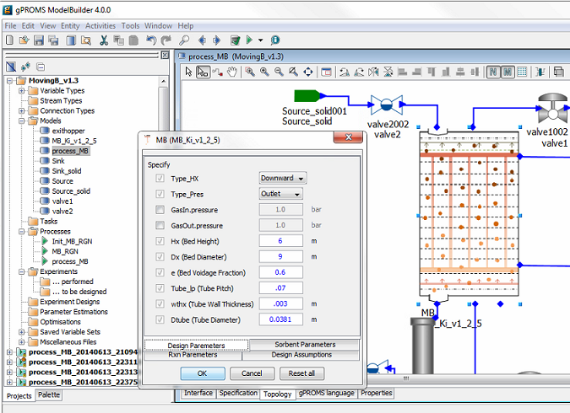

Figure 5: Specification box for MB model.  
The process flowsheet model “process_MB” is highlight in the “project tree” menu on the left.

**Note:** Specifying the required variables is done by double-clicking each piece of process equipment under the “Topology” tab of the “process_MB” window (Figure 20). These values are set to default values. Like the ACM model, if these variables are changed, it may require an initialization procedure. This can be turned on or off in the next step by selecting “Execute” or “Ignore” (Figure 21).

1. Run the model by clicking “Play” (the green button on the top of the toolbar). The “Simulate” option menu displays. Be sure the check box for “Ignore schedule and intrinsic tasks” is cleared (see Figure 21) to run a dynamic simulation. This runs the schedule already set up (it introduces a disturbance) which can be viewed by opening the “process_MB” under the “Processes” folder in the “project tree” and then navigating to the “Schedule” tab. Select the check box to run a   
   steady-state simulation. Additionally, change the reporting interval to “1.0.”

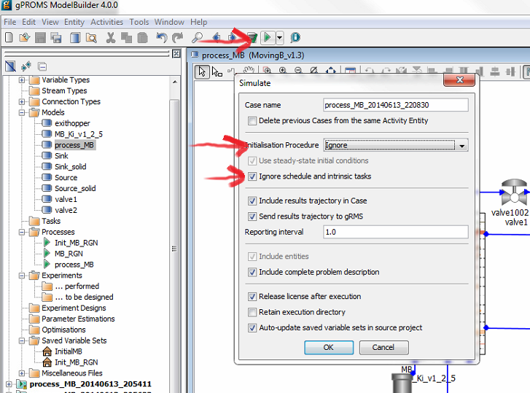

Figure 6: Click “Play” (the green button on the top of the toolbar)  
while the “process_MB Model” window is open to open the “Simulate” window.  
The “Initialisation Procedure” drop-down menu enables the user  
the option to run the initialization procedure.  
Select the “Ignore schedule and intrinsic tasks” check box to run a steady-state model.

1. Click “OK” on the “Simulate” options window to begin the simulation.
2. A new results window displays (listed at the bottom of the “project tree”).
3. A simulated ramped increase in inlet solid’s temperature occurs at 10s and the simulation time is 180s.
4. To view the results navigate to the “Trajectories” → “Flowsheet” → “MB” → “Variables” folder in the results file that is generated at the bottom of the “project tree” (see Figure 22). Find the variable “SolidCompflow,” double-click the variable, and then click the “Graph” tab at the bottom of the window to generate a plot.
5. Select the time to be fixed at “0,” the axial to be the x-axis and the “ionslist” to be a “series.” The resulting graph is given in Figure 23.
6. Select the time to be the y-axis, and the “ionslist” to be “H2O.” This will plot a 3-D plot of the bed profile through time. It can be seen in Figure 24.

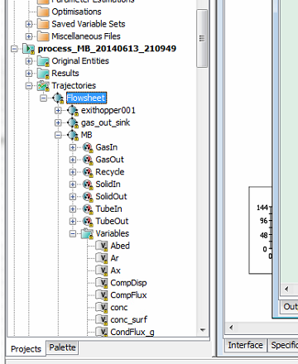

Figure 7: After a simulation begins, the “Results” folder displays at the end of the “project tree.”  
Navigate to the “Trajectories” → “Flowsheet” → “MB” → “Variables” folder  
to examine the results of a successful simulation.

**Note:** Plots can also be made using the gRMS program in a similar fashion with more options with the ability to save a template for the plots, allowing plots to be generated quickly for new simulation results.

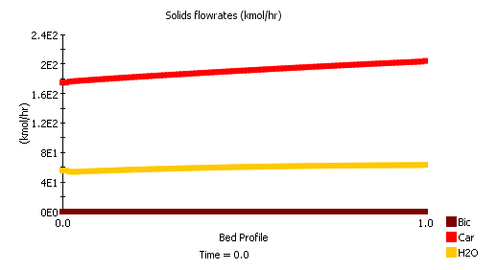

Figure 8: Steady-state profile of component solid flow through the reactor.

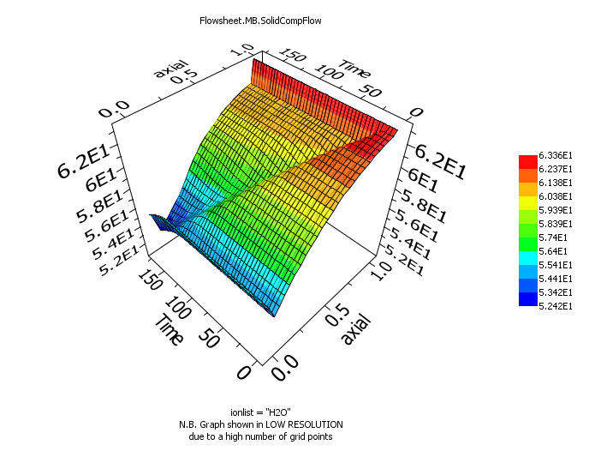

Figure 9: Dynamic profile of physiorbed H2O solid flow through the reactor  
from a simulated ramp in the inlet solid temperature.

1. Installation Requirements

The minimum suggested hardware requirement is a desktop/laptop running Windows® 7 on an Intel Core i-5 family 2.8 GHz or faster and 8 GB of RAM. With lower configuration, the simulation speed can be slower. The ACM and gPROMS models have been tested on Aspen® V8.4 and gPROMS ModelBuilder 4.0.0, respectively.

1. Reference

[1] Lee, A., Mebane, D.S., Fauth, D.J., and Miller, D.C., “A Model for the Adsorption Kinetics of CO2 on Amine-Impregnated Mesoporous Sorbents in the Presence of Water,ˮ Pittsburgh Coal Conference, 2011.